 | 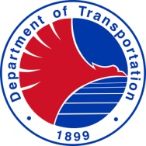 | Republic of the Philippines | 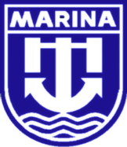
 |  | Department of Transportation
 |  | MARITIME INDUSTRY AUTHORITY

FORM __: ENROLMENT REPORT

(Name of Maritime Training Institution)

Course: _________________________________ Class No.: _______________________
Class Schedule: __________________________ Bldg. & Room No. _________________
Practicum Site/Vessel: _____________________ Practicum Date: ___________________
Lead Instructor: ___________________________ Assessor: ________________________
Alternate Instructor: _______________________ Alternate Assessor: ________________

No. | Name of Trainees | Date of Birth | Rank/Rating/  Position | Date of  Enrolment | Signature of  Enrollees
1
2
3
4
5
6
7
8
9
10
11
12
13
14
15
16
17
18
19
20
21
22
23
24
(Name of school if class is under MOA with Maritime Higher Education Institution)

Certified Correct:

___________________________ ___________________________
Training Director President
(Signature over Printed Name) (Signature over Printed Name)
ACCRE NO.: 10-01
Initial Issue Date: 07-03-2012
Revision Date: 03-04-2013

